EXP 02
Write JavaScript Programme to validate the following fields of the HTML Registration page.

AIM:
To write JavaScript code to validate user input in a registration form. The validation will ensure that the data entered by the user meets specific criteria for each field. This will help in maintaining data integrity and prevent invalid submissions.

ALGORITHM:
1. Input:
- The user fills in the following fields: First Name, Password, E-mail, Mobile Number, Last Name, and Address.
2. Validation Steps:
- Validate First Name:
  - Check if the first name contains only alphabets.
  - Ensure the length of the First Name is at least 6 characters.
  - If any of these conditions fail, display an error message indicating the required input.
- Validate Password:
  - Check if the password is at least 6 characters long.
  - If it is less than 6 characters, display an error message.
- Validate E-mail:
  - Use a regular expression to check if the email follows the standard pattern: name@domain.com.
  - Ensure that the email contains no invalid characters and matches the required pattern.
  - If it doesn't match, display an error message indicating an invalid email format.
- Validate Mobile Number:
  - Check if the mobile number contains exactly 10 digits.
  - Ensure there are no alphabets or special characters.
  - If the number is invalid, display an error message indicating the correct format.
- Validate Last Name:
  - Ensure the Last Name field is not empty.
  - If it is empty, display an error message.
- Validate Address:
  - Ensure the Address field is not empty.
  - If it is empty, display an error message.
Program:

Registration.html:

<html>
<head>
<meta charset="UTF-8">
<title>Online College Notice Board - Registration</title>
<link rel="stylesheet" href="style.css">
<script src="validate_reg.js"></script>
</head>
<body>
<div class="container">
<h2>Student Registration Form</h2>
<form name="regForm" onsubmit="return validateForm()">
<div class="form-grid">
<div>
<label>First Name</label>
<input type="text" name="fname">
</div>
<div>
<label>Last Name</label>
<input type="text" name="lname">
</div>
<div>
<label>Roll Number</label>
<input type="text" name="roll">
</div>
<div>
<label>Department</label>
<select name="dept">
<option value="">--Select Department--</option>
<option>CSE</option>
<option>AIML</option>
<option>ECE</option>
<option>EEE</option>
<option>MECH</option>
</select>
</div>
<div>
<label>Year</label>
<select name="year">
<option value="">--Select Year--</option>
<option>1</option>
<option>2</option>
<option>3</option>
<option>4</option>
</select>
</div>
<div>
<label>Gender</label>
<div class="gender">
<input type="radio" name="gender" value="Male"> Male
<input type="radio" name="gender" value="Female"> Female
</div>
</div>
<div>
<label>Email ID</label>
<input type="text" name="email">
</div>
<div>
<label>Mobile Number</label>
<input type="text" name="mobile">
</div>
<div>
<label>Password</label>
<input type="password" name="password">
</div>
<div class="full">
<label>Address</label>
<textarea name="address"></textarea>
</div>
<div class="full terms">
<input type="checkbox" name="terms"> I agree to the Terms & Conditions
</div>
</div>
<input type="submit" value="Register">
</form>
</div>
</body>
</html>

Style.css:
:root {
--primary-color: #004aad;
--secondary-color: #f2f6ff;
--accent-color: #ff9800;
--text-color: #333;
}
body {
margin: 0;
font-family: "Segoe UI", Arial, sans-serif;
background-color:lightblue;
}
.container {
width: 460px;
margin: 50px auto;
background-color: white;
padding: 25px;
border-radius: 8px;
box-shadow: 0 0 12px rgba(0,0,0,0.15);
}
h2 {
text-align: center;
color: #003080;
}
label {
display: block;
margin-top: 12px;
font-weight: 600;
}
input, select, textarea {
width: 100%;
padding: 8px;
margin-top: 5px;
border-radius: 4px;
border: 1px solid #ccc;
}
textarea {
resize: none;
height: 70px;
}
.gender {
margin-top: 5px;
}
.gender input {
width: auto;
margin-right: 5px;
}
.terms {
margin-top: 15px;
}
.terms input {
width: auto;
}
input[type="submit"] {
margin-top: 20px;
background-color: var(--primary-color);
color: white;
font-size: 16px;
border: none;
cursor: pointer;
padding: 10px;
border-radius: 5px;
}
input[type="submit"]:hover {
background-color: #003080;
}
.form-grid {
display: grid;
grid-template-columns: repeat(2, 1fr);
gap: 15px;
}
.form-grid .full {
grid-column: span 2;
}
@media (max-width: 600px) {
.form-grid {
grid-template-columns: 1fr;
}
.form-grid .full {
grid-column: span 1;
}
}

validate_reg.js:
function validateForm() {

let roll = document.regForm.roll.value;
let fname = document.regForm.fname.value;
let lname = document.regForm.lname.value;
let dept = document.regForm.dept.value;
let year = document.regForm.year.value;
let gender = document.regForm.gender;
let email = document.regForm.email.value;
let mobile = document.regForm.mobile.value;
let password = document.regForm.password.value;
let address = document.regForm.address.value;
let terms = document.regForm.terms.checked;
let rollPattern = /^[A-Za-z0-9]{6,12}$/;
if (!rollPattern.test(roll)) {
alert("Roll Number must be 6–12 alphanumeric characters");
return false;
}
let namePattern = /^[A-Za-z]{6,}$/;
if (!namePattern.test(fname)) {
alert("First Name must contain only alphabets and minimum 6 characters");
return false;
}
if (lname.trim() === "") {
alert("Last Name cannot be empty");
return false;
}
if (dept === "") {
alert("Please select a Department");
return false;
}
if (year === "") {
alert("Please select Year");
return false;
}
if (!gender[0].checked && !gender[1].checked) {
alert("Please select Gender");
return false;
}
let emailPattern = /^[^\s@]+@[^\s@]+\.[^\s@]+$/;
if (!emailPattern.test(email)) {
alert("Enter a valid Email ID");
return false;
}
let mobilePattern = /^[0-9]{10}$/;
if (!mobilePattern.test(mobile)) {
alert("Mobile Number must contain exactly 10 digits");
return false;
}
if (password.length < 6) {
alert("Password must be at least 6 characters long");
return false;
}
if (address.trim() === "") {
alert("Address cannot be empty");
return false;
}
if (!terms) {
alert("Please agree to the Terms & Conditions");
return false;
}
alert("Registration Successful!");
return true;
}

Output:

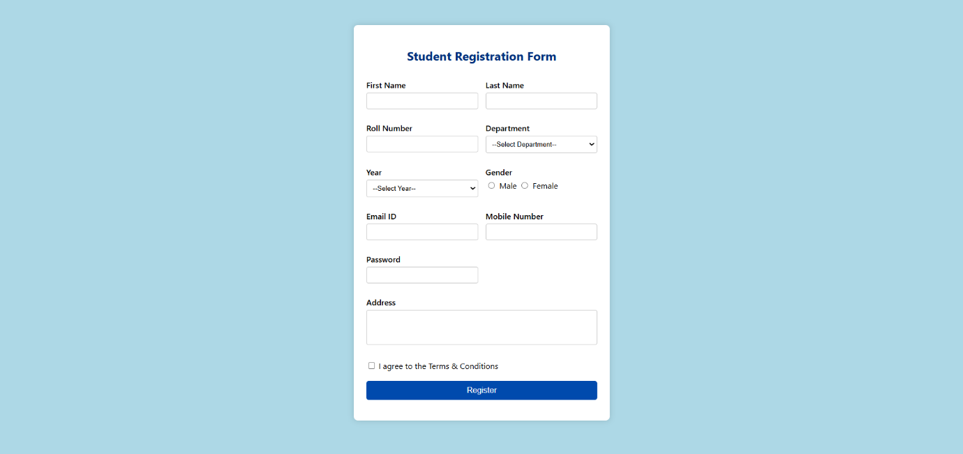

RESULT:
HTML page with Form is created and is validated using Javascript.

